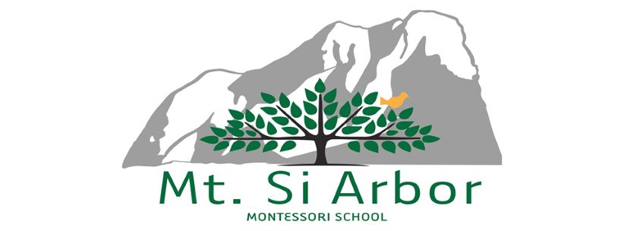  
  
PARENT-SCHOOL PARTNERSHIP AGREEMENT

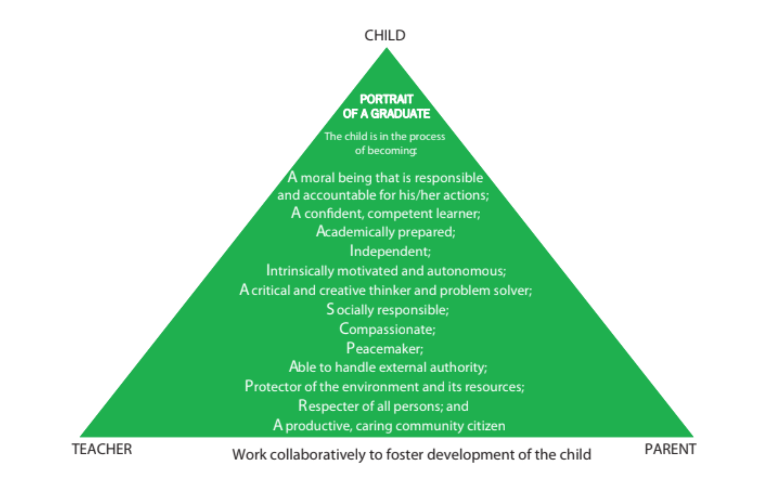

|  |  |
| --- | --- |
| TEACHER | PARENT |
| **Classroom Architect, Builder, and Guardian:** Continually creates a classroom environment to meet the changing needs of the children (cognitive, physical, emotional, and social). Establishes and enforces classroom rules, routines, and procedures. Identifies volunteer opportunities and coordinates volunteer efforts to meet classroom needs. | **Lifetime Role Model:** Promotes development of independence, responsibility, and accountability of the child by modeling and reinforcing desired behaviors. Provides boundaries and choices; uses logical consequences in discipline. |
| **Instructional Designer, Facilitator, and Assessor:** Passionate about meeting the child’s needs using Montessori philosophy and methodology. Provides individual children with appropriate, challenging work. Shares information with parents regarding academic and developmental progress. | **Respecter of Montessori Professional:** Seeks to understand how things are done in a Montessori classroom. Actions reinforce the Montessori approach and support the fundamental Montessori tenet of the teacher’s authority in the classroom. |
| **Classroom Role Model:** Promotes development of independence, responsibility, and accountability of the child by modeling and reinforcing desired behaviors. Provides boundaries and choices; uses logical consequences in discipline. | **Collaborative Problem-Solver:** Partners with teacher in problem solving to improve the educational experience for the child. |
| **Classroom Authority:** Works with child in a manner consistent with Montessori philosophy; respects the child and provides freedom within limits. | **Instructional Supporter**: Passionate about learning about the Montessori method. Attends parent/teacher conferences and workshops. Asks the classroom teacher, “What can I do to support my child?” Follows through on agreed-upon steps. |
| **Facilitator of Problem-Solving:** Promotes development of the child’s problem-solving skills. Asks questions to help the child solve his/her own problems rather than solving problems for him/her. Allows child to experience consequences of his/her actions. | **Facilitator of Problem-Solving:** Promotes development of the child’s problem-solving skills. Asks questions to help the child solve his/her own problems rather than solving problems for him/her. Allows child to experience consequences of his/her actions. |
| **Collaborative Problem-Solver:** Partners with parent in problem solving to improve the educational experience for the child. | **Volunteer:** Volunteers time, energy, and resources to identified school/classroom needs. Asks teachers, “How can I help?” Parent follows the lead of the classroom teacher in working in the classroom and respects his/her classroom guidelines and processes. |

PARENT-SCHOOL PARTNERSHIP AGREEMENT

WORKING RELATIONSHIPS AT ARBOR MONTESSORI SCHOOLS — SETTING EXPECTATIONS FOR PARENTS AND THE SCHOOL

**Background**

The purpose of this agreement is to clarify expectations. What can parents and school expect of each other as we enter into a long-term partnership to aid the development of your children? This document seeks to answer that question by articulating expectations: those that parents can reasonably expect of the school and, in turn, what the school, with its mission of providing a superior Montessori learning environment, will expect of parents. By publishing a dialogue based on important questions and answers contained in this Agreement, we aim to reduce the misunderstanding and disappointment that can result when unstated expectations go unmet.

WHAT DOES THE SCHOOL EXPECT FROM PARENTS?

***Q. What is the school’s most basic expectation of parents?   
A. Make continuing efforts to understand, embrace, and apply the Montessori approach at home and to work in partnership with the school.***

These efforts should begin before admission. The school desires parents who understand and embrace the mission of the school. To that end, we help parents learn about the Montessori approach by providing information and opportunities for parent education as part of the admission process—so that parents can make an informed decision in choosing to enroll their children—and continue to provide more opportunities throughout a family’s years at the school.

Once children are enrolled, the school expects parents to attend regularly scheduled Parent-Teacher Conferences and parent development events and to familiarize themselves with the philosophy, policies, and procedures contained in the Parent Handbook and other school publications.

Children thrive when both the home and school environments work in harmony, sharing the same educational values and expectations. Children develop a love of learning and become responsible, independent, and capable when parents’ values and expectations are consistent with those of the school and are reinforced on a consistent basis at home.

The school expects parents to commit to growth in parenting in a Montessori way. We have defined the real “work” of a parent, in a collaborative partnership with the school, as modeling the attributes for their child and providing opportunities for their child to develop them at home. In other words, parents are expected to become proficient in applying Montessori philosophy at home. This begins with the general principle, “Never do something for your child that he can do for himself.” Allow your child to engage in all of the simple tasks of everyday life that a child can do for himself at each stage of development. Montessori education may also entail learning a communication style that is different from the way in which you were parented. This is a commitment that takes time and will likely involve change, which typically involves some level of discomfort. However, you are not alone or isolated in your journey of growth as a parent. Arbor staff and other Arbor families are your support system. In this school, we are all members of a Montessori learning community.

***Q. What contribution can I make to create a positive school community?***

***A. Demonstrate respect for all adults and children, the school, and the school’s programs and become involved in the life of the school community by giving of your time, talents, and finances.***

Model respect for your children—for them, their classmates, parents of classmates, teachers and other school staff—in short, for everyone associated with the school. Respect begins with civility and deepens into trust. Our most fundamental behavioral guidelines for the children are: “respect yourself, respect others, and respect the environment.” We expect the same from adults, parents, and school staff, at all times and in all relationships   
within the school community. We expect every member of our community, students, parents, and staff, to be willing to accept full responsibility for their attitudes, actions, and ultimately for their lives. This includes speech and outward behavior. Support your child by speaking of his/her teachers, classmates, and school in positive terms. Respect and abide by the school’s policies and procedures. Follow the school’s problem solving process when you have a concern. Honor your commitments. Look for ways to make a positive contribution to the life of the school. Through your behavior, you contribute to your children’s moral development and to the culture and climate of our school, which they experience on a daily basis.

Get involved in the life of the school community. At Mt. Si Arbor, parent involvement is not only strongly encouraged, but is an integral part of everyday life. Involvement opportunities range from serving in the classroom to heading one of our parent driven community events. More information on involvement opportunities can be found in the Parent Handbook. Other sources of information about involvement opportunities include classroom teachers, the weekly eNewsletter (Weekly Notes), and front office staff. You can make a difference. Find your area of interest and get involved. If you need help getting connected, contact another parent or staff member; we would be happy to help you identify your niche. Not only will your child benefit by your interest and participation, faculty will greatly appreciate your involvement.

***Q. What are my responsibilities regarding communication and problem solving between home and school?   
A. Maintain active, direct, and respectful, two-way communication with the school.***

Read communications that are sent out by Mt. Si Arbor, including emails, Weekly Notes, and Transparent Classroom posts as well as information posted on our website. Inform the school in a timely fashion of pertinent changes in your child’s life. Parents are responsible for keeping contact information current and informing the school of any changes in custodial arrangements. If the custodial arrangements of your child have changed since you enrolled the child, it is your responsibility to provide a copy of the current court order to the school.

Active communication involves parents sharing observations and concerns about their child with the child’s current teacher. In matters large and small, remember the principle of respect; even when there is disagreement, disagree respectfully, and follow the school’s problem-solving process. For more detailed communication guidelines, please refer to the Parent Handbook.

Children prosper most when the adults in their lives work in harmony and resolve conflict through side-by-side problem solving rather than face-to-face confrontation or by involving others who are not part of the problem or the solution. Asking for information, striving to see other perspectives, and remaining open to possible solutions are critical elements of collaborative problem solving.

WHAT CAN PARENTS REASONABLY EXPECT FROM THE SCHOOL?

***Q. What can I expect of the school academically?  
 A. Arbor Montessori School aspires to fulfill its mission as a Montessori school.***

As a Montessori school, we are different from traditional schools. Our first commitment is to the multidimensional development of the child. Mt. Si Arbor’s curriculum is challenging and you can expect your child to be provided with challenging work that is appropriate for her. Parents of our graduates report that their children are well prepared, academically, for middle school in area private or public schools. It is not unusual for children working “at-level” at Mt. Si Arbor to report that they are on the “A” honor roll at other schools, while children working “above-level” at Mt. Si Arbor are significantly ahead of their peers, particularly in math. However, our aim is for each child to be far more than a repository of information. We guide each child to think for herself. Cognitive development and a solid academic foundation are important, yet they represent only one dimension of our

aspirations for your child. Equally significant is your child’s social, emotional, spiritual, and physical development. Outcomes of a Mt. Si Arbor education are contained within our Portrait of a Graduate document, available on our website.

Children are given choices and a great deal of freedom—within limits—during the school day. They are allowed to experience, and learn from, the consequences of their choices thereby strengthening their critical thinking skills and promoting self-correction. The choices a child makes and the accompanying responsibilities influence the emerging character of your child. Choosing his own work, or shaping it to a considerable degree, following that work through to completion, while working independently or in cooperation with others, the Montessori child identifies his interests and develops his individual gifts with the goal to strengthen intrinsic motivation and self- direction.

We treat each child with dignity and respect, and expect that she will treat all others with the same respect. We treat each child as an individual and strive to develop each child’s unique gifts—within the context of the classroom and the school community. With freedom comes responsibility, and each child learns to balance his personal freedom with a clear sense of responsibility to herself, to others, and to the community as a whole.

***Q. What can I expect in terms of communication from the school?  
 A. We strive to maintain open, honest, timely, and respectful communication with you about your child* *and about information affecting the school community.***

Beginning in the Primary Classroom, there are two regularly scheduled Parent-Teacher Conferences each year, as well as two written progress reports. In the event of special concerns, your child’s teacher will contact you to discuss these concerns by phone, by email, or in person. If you have a concern or question about your child’s classroom or progress, please contact the classroom teacher before talking to administrative staff. Additional communication guidelines are found in the Parent Handbook. In addition to conference reporting, classroom teachers will communicate with you in person, through Transparent Classroom, and via email messages and short reports as needed for individual children.

Each Mt. Si Arbor teacher is a highly-trained professional and her evaluation is confidential and based on direct observation of your child. She will always offer her current, best understanding of your child’s progress and his strengths and needs. For all children, this evaluation is based on the teacher’s observation, which may be augmented by input from administrative staff. Should it ever become clear that a child is not benefiting from the school’s program and outside professional assistance is needed, or if the school is not the best program to meet the child’s needs, we will immediately schedule a meeting with parents.

School-wide communication is accomplished in several ways; the school produces a weekly eNewsletter (weekly notes), as well as the Parent Handbook, school calendar posted on our website, occasional emails, Transparent Classroom postings daily, and other publications. We also invite you to attend Open House events as well as parent development opportunities happening throughout the year.

***Q. What can I expect of the school environment?   
A. We strive to ensure an environment that is physically and emotionally safe and supportive, as well as aesthetically beautiful.***

Dr. Montessori said that the classroom teacher’s first responsibility is to prepare the environment. This means that the learning materials should correspond to the developmental characteristics of the child at each level. It is important that those materials be attractive to the child: correct in size, aesthetically pleasing, well maintained, and complete. In a broader sense, the whole school environment must meet these criteria: to appeal to the child and to inspire his work.

We are ever vigilant to ensure that the school building and grounds are physically safe, secure, and well maintained. If you notice something that needs to be addressed, please bring it to the attention of administrative staff.

Our community of children and adults comprise a social environment and culture that impacts the child’s experience. We strive to make this environment emotionally supportive and safe for every child. This does not mean that there are no problems. It does mean that we will work with your child in developmentally appropriate ways to deal with problems as they arise, empowering him with problem-solving and social skills and aiding him in the development of emotional intelligence to prepare for a lifetime of working with others in a variety of communities and organizations.

***Q. What professional standards can I expect of the school and faculty?  
A. The school maintains membership in the American Montessori Society (AMS) and high standards for training and professionalism among its faculty.***

Mt. Si Arbor is a member school of the American Montessori Society (AMS) and its educational program will be submitted to the exacting accreditation standards. Mt. Si Arbor’s programs are licensed by the Washington State Department of Early Learning. The school has also sought to measure its educational program against State Montessori having its 3 to 6 program verified by the Pacific Northwest Montessori Association.

At minimum, all Toddler and Early Childhood classroom teachers have a Montessori teaching credential, for the age group they teach, from a MACTE (Montessori Accreditation Council for Teacher Education) accredited teacher-training center. In addition, all lead teachers have a college degree. Our teachers have a sense of mission in working with children and demonstrate high standards for themselves and their students.

The school promotes a culture of professional growth in a number of ways. Annually, teachers, in collaboration with the Head of School, identify areas of desired or needed professional development. In addition to workshops and study groups on-site, teachers are required to attend workshops and conferences, locally and out-of-state for a total annual minimum of 10 hours.

***Q. What can I expect of the school administration?   
A. Integrity; a focus on the needs of the individual child in harmony with the life of the community; mission-driven decisions embodying good stewardship and responsible management; and an open door to your questions or concerns.***

Administrative staff interfaces with all of the various constituencies of the school: students, parents, extended family, faculty, alumni, prospective parents, professional visitors, government officials, other schools and educational organizations, as well as the general public. In your interactions with administration, you can expect professional, courteous, and business-like conduct, as well as mutually respectful communication. The Head of School and Owner of School comprise the administration team. They often face decisions requiring a balance of competing priorities. Sometimes those factors are mutually exclusive; sometimes equally well-intentioned adults see matters differently. In making decisions, administration will focus on the interest of the individual child in balance with the needs of the school. To schedule a meeting with the Head of School please contact the front office.



Parent-School Partnership Agreement Acknowledgement

I/We have read, understand, and agree to follow the Parent-School Partnership Agreement described within.

_________________________________________________________

Student(s) Name(s)

_____________________________ ______________________

Parent/Guardian signature Date

_____________________________ ______________________

Parent/Guardian signature Date

_____________________________ ______________________

Teacher signature Date